Who Evaluates the Evaluators? — Project Proposal
Oct 7, 2026 · Pritam Chakraborty

Summary
This project tests whether the benchmarks and simulators used to rank self-driving policies actually rank them correctly, and fixes them where they do not. We build families of driving policies whose true quality order is known by construction, run them through every major evaluator (op
en-loop, pseudo-simulation, 3D Gaussian splatting simulation, generative world models), and measure which evaluators recover the true order for which kinds of failure. We then propose a reliability-weighted score that down-weights scenarios where an evaluator's verdict cannot be trusted. Target venue: CVPR 2027 (paper deadline 16 Nov 2026 AoE).

Background
A driving policy is a model that maps sensor input (cameras, sometimes LiDAR) to a planned trajectory. Since 2024 the field has moved to end-to-end policies and, in 2025–2026, to large vision-language-action (VLA) models such as NVIDIA's Alpamayo-R1. Real-world road testing is expensive and unsafe at research scale, so almost every paper ranks policies with a proxy evaluator.
Evaluator family | Example | How it scores | Main known weakness
Open-loop distance | nuScenes L2 / ADE | Distance between predicted and logged human trajectory | Ignores compounding errors; does not reflect closed-loop performance
Non-reactive pseudo-simulation | NAVSIM v1 PDMS | Short BEV rollout with fixed other agents | Other agents never react to the ego car
Two-stage pseudo-simulation | NAVSIM v2 EPDMS (navhard) | Re-scores from synthesized views around the first plan's endpoint | R² ≈ 0.8 with closed loop; 20% of variance unexplained
3DGS reactive simulation | HUGSIM | Closed-loop driving in reconstructed real scenes | Rendering degrades when the car leaves the recorded path
Generative world model | Video world models (e.g. Cosmos-style) | Closed-loop rollout in generated video | Realistic texture but physical and behavioral errors (WorldLens)
Graphics simulator | Bench2Drive (CARLA) | Closed-loop driving score over 220 routes | Synthetic sensor domain gap
Papers routinely claim gains of 1–2 points on these scores. Whether such gains reflect better driving is the question this project answers.

Problem statement
The field ranks driving policies with proxy evaluators whose ability to rank policies correctly has never been measured against a known ground truth. If an evaluator is blind to a type of failure, a policy that has that failure can still top the leaderboard, and research effort follows a misleading signal.
Research question. For each evaluator family, which kinds of policy failure can it detect, how reliably does it rank policies, and can we tell, scenario by scenario, when its verdict should not be trusted?
Evidence that the problem is real and unsolved:
- Benchmarks disagree. A 2026 cross-benchmark study found that NAVSIM PDM Score and Bench2Drive Driving Score correlate positively but with clear ranking inversions (arXiv 2605.00066).
- Benchmarks can reward non-driving behavior. On non-reactive navtest, a plain MLP controller slightly beats physically grounded vehicle models because scoring reduces to matching a fixed future (arXiv 2602.06214).
- Generative simulators are unreliable exactly where it matters. Driving world models trained on mostly safe driving produce severe physical inconsistencies under counterfactual trajectories (PhyGenesis), which are what a policy under test produces.
- No ground truth exists. Real-world closed-loop results for many public policies are unavailable, so every existing comparison is evaluator against evaluator, never evaluator against truth.
The core obstacle is the last point. This project removes it by constructing the ground truth (see Key idea).

Related work and the gap
Prior work evaluates either the realism of simulators or correlations between published numbers; none tests evaluators against a known policy ordering in driving.
Work | What it did | What it leaves open
Drive&Gen (Waymo, IROS 2025) | Judges realism of generated driving video from an E2E planner's view | Does not test whether the simulator ranks policies correctly
NAVSIM v2 / pseudo-simulation | R² = 0.8 agreement with closed loop | One evaluator family; unexplained variance
Open-loop vs closed-loop study (Apr 2026) | Correlates published NAVSIM and Bench2Drive numbers | Only 8 paired methods, no new experiments, confounded training setups
WorldLens (CVPR 2026) | Scores world models on realism, geometry, physics, behavior | Evaluates the world model, not its use as a policy judge
WorldGym, WorldEval, RoboWorld | Show world-model scores preserve robot policy rankings | Robotics manipulation, not driving; one evaluator family
Gap. No driving study runs one policy population through every evaluator family under controlled conditions, measures ranking correctness against a known order, and offers a way to detect unreliable verdicts per scenario.
Adjacent directions checked and judged crowded: chain-of-thought faithfulness in driving VLAs (Pinocchio, Jul 2026; CF-VLA, CVPR 2026; VLADriveBench).

Key idea: ground truth by construction
We cannot observe the true quality of a policy, but we can create policies whose quality order we know. Take a strong pretrained policy and corrupt it in graded steps (level 0 = original, level 3 = most corrupted). For a fixed policy and corruption type, quality must fall as the level rises, so any evaluator that does not rank level 0 > 1 > 2 > 3 is blind to that failure.
Example: blank out 0, 1, 2 or 4 of the 8 cameras. An evaluator that scores all four versions the same cannot detect perception failures.
This gives a test with a known answer, needs no real-world driving, and needs no new model training. The assumption that more corruption means worse driving is itself checked before use (Workflow, stage 2).

Contributions
The paper will make four contributions; the first two hold regardless of how the experiments turn out.
- A ground-truth ordering test for driving evaluators. A protocol that builds policy populations with known performance order (graded degradations of pretrained policies) and checks the order with a statistical monotonicity test before use.
- The first controlled cross-evaluator study in driving. One policy population run through open-loop, NAVSIM v1, NAVSIM v2, a 3DGS closed-loop simulator and a generative world model, reporting a discriminative-power matrix: which evaluator detects which failure type, with bootstrap confidence intervals.
- Reliability-weighted evaluation (method). A per-scenario reliability score r(s), predicted from cheap signals, that down-weights scenarios where the evaluator's verdict is unreliable; validated on held-out policies and held-out failure types.
- An open evaluation harness. Code that wraps any policy and any evaluator, so new methods and simulators can be audited the same way.

Hypotheses
Each hypothesis can fail, and a failed H1 or H2 is still a publishable finding.
ID | Hypothesis | Test | Falsified if
H1 | Open-loop and non-reactive evaluators miss latency and memory failures, which only show when errors compound | Ordering recovery per evaluator × degradation | They order these degradations as well as closed-loop evaluators
H2 | World models detect perception failures but miss action failures | Same matrix, world-model row | Action-degradation ordering is as good as perception
H3 | Evaluator reliability is predictable per scenario from cheap signals | AUROC of r(s) for predicting correct ordering | AUROC ≤ 0.7
H4 | Reliability weighting improves ranking on unseen policies | Kendall τ, weighted vs uniform, on held-out data | No significant gain (bootstrap CI includes 0)

Method
The method has four parts: policy populations, evaluators, ranking metrics, and the reliability-weighted score.

Policy populations
Population | How it is made | Ordering | Training
A: degraded | Code wrappers around 2–3 pretrained policies (e.g. TransFuser, Latent TransFuser) that corrupt input or output at 4 levels | Known by construction | None
B: natural | 8–12 public pretrained checkpoints trained on the same data (NAVSIM) | Unknown | None (download)
C: checkpoints | Weights saved at several epochs of one cheap training run (Latent TransFuser), or several seeds | Approximately known | One run
Degradations used in Population A (level 1 → level 3):
Type | What it breaks | Severity range
Camera dropout | Perception | 1 → 4 cameras blanked
Image noise | Perception | Gaussian σ = 10 → 50 pixel values
Stale observation | Timing | Acts on frames 0.5 → 1.5 s old
Latency queue (closed-loop only) | Timing | Action applied 1 → 4 steps late
History removal | Temporal memory | 66% → 0% of past frames kept
Lateral noise | Control | 0.3 → 1.5 m drift
Late braking | Control | Trajectory stretched 15% → 70%
A degradation is kept only if the most trustworthy (closed-loop) evaluator shows a significant drop at every step, bootstrap P(drop > 0) > 0.95.

Evaluators
Open-loop L2, NAVSIM v1 PDMS, NAVSIM v2 EPDMS (navhard), HUGSIM (3DGS closed loop), and one open action-conditioned driving world model. Bench2Drive (CARLA) is included only for within-evaluator ordering tests, because its policies are trained on a different domain and raw scores are not comparable.

Ranking metrics
- Ordering recovery (Population A): fraction of correctly ordered level pairs and Kendall τ against the known order, per evaluator × degradation.
- Agreement (Populations B and C): Kendall τ, Spearman ρ and MMRV (mean maximum rank violation) between evaluators.
- Uncertainty: 1,000-sample bootstrap over scenarios for 95% confidence intervals; permutation tests for τ > 0.
- Sample efficiency: τ as a function of the number of scenarios used.

Reliability-weighted score
A scenario s is labelled reliable for an evaluator if it orders the Population A levels correctly. A light model (logistic regression or a small MLP) predicts reliability r(s) ∈ [0, 1] from cheap signals: deviation of the rollout from the logged path, frame consistency of world-model output, and the gap between NAVSIM v2 stage 1 and stage 2 scores. The corrected benchmark score is:
S_w(\pi) = \frac{\sum_s r(s)\, \mathrm{score}(\pi, s)}{\sum_s r(s)}
Fallback if r(s) is not predictive: select the smallest scenario subset that maximises ordering recovery and release it as a discriminative benchmark split.

Workflow
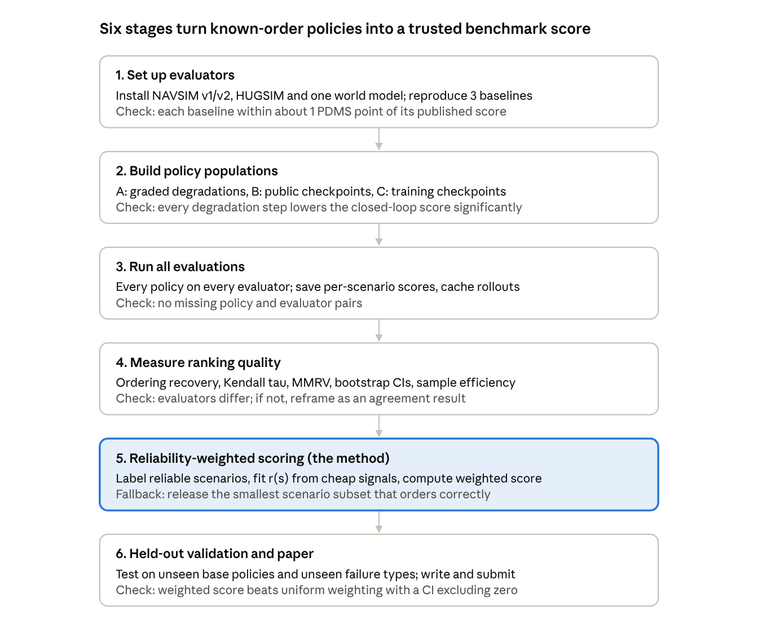
project workflow · 6 stages, each with its go/no-go check
Stages 1–4 are the study, stage 5 is the method, and stage 6 tests whether the method generalises. Each stage ends with a check; a failed check triggers the fallback named in Risks rather than stopping the project.

Timeline
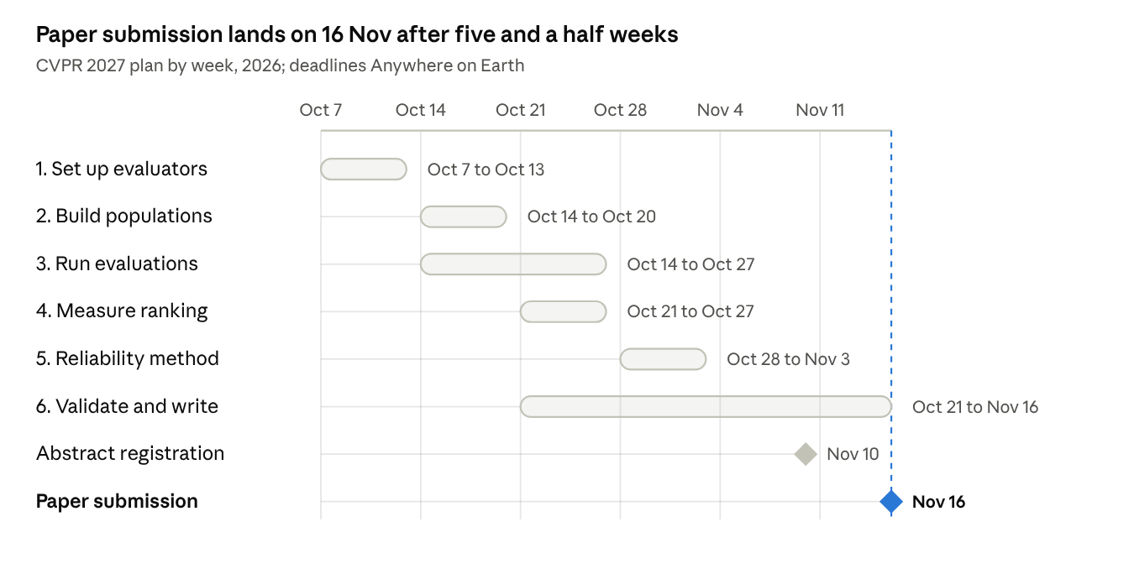
CVPR 2027 plan · 7 Oct to 16 Nov 2026
Writing starts in week 3, alongside analysis, because the final week is always shorter than planned. Deadlines from the CVPR 2027 call for papers: mandatory registration 10 Nov, paper 16 Nov 2026 AoE.

Resources and compute
The project is inference-heavy and training-light; closed-loop rollouts are the main cost. Figures below are planning estimates to confirm in week 1.
Item | Estimate | Note
Policy variants | about 64 | 3 bases × 4 degradations × 4 levels, plus 10 natural, plus 6 checkpoints
Evaluators | 4–5 | Scenario counts reduced per evaluator if needed, justified by the sample-efficiency analysis
GPUs | 4–8 modern GPUs for 3–4 weeks | With fewer, run the world model on a smaller scenario subset rather than dropping it
Training | One Latent TransFuser run for Population C | Plus a small reliability model (minutes)
Data | NAVSIM (navtrain, navtest, navhard), simulator scene assets | Check licences and disk space before download
To verify before committing: each public checkpoint loads and reproduces its reported PDMS within about ±1; HUGSIM and the chosen world model accept the policies' camera setup.

Risks, limitations and reviewer objections
The biggest risk is time: about five weeks to the deadline. Each risk has a fallback decided in advance.
Risk or objection | Response or fallback
"Synthetic degradations are not real failures" | Populations B and C add natural policies; degradations mirror documented real failures (sensor loss, latency)
"Only about 10 policies" | Population A gives dozens of variants with known order; bootstrap CIs on every number
"Just a benchmark study, no novelty" | Reliability-weighted scoring is the method; shown to generalise to held-out policies and failure types
"Overlaps with Drive&Gen and the April 2026 study" | Cite both; state the difference: they measure realism or correlate published numbers, we test ordering against a known truth
A degradation is not monotone | Drop it and report it; the monotonicity check is part of the protocol
A simulator will not run with our policies | Replace it in week 1; the harness is evaluator-agnostic
Reliability score not predictive (H3 fails) | Switch to the discriminative-subset fallback
Concurrent work appears | Papers online after 15 Sep 2026 count as contemporaneous for CVPR 2027; still cite and differentiate
Limitation stated openly in the paper: known ordering is relative within one base policy and one degradation type; it does not give absolute real-world quality.

Glossary
Term | Meaning
Policy | A model that maps sensor input to a planned trajectory
End-to-end (E2E) driving | One network from sensors to trajectory, instead of separate perception, prediction and planning modules
VLA | Vision-language-action model: a multimodal language model that also outputs driving actions
Open-loop evaluation | Compare predicted and logged trajectories; the policy's actions do not change what happens next
Closed-loop evaluation | The policy drives; its actions change future observations, so errors can compound
Pseudo-simulation | NAVSIM v2's middle ground: short rollouts plus re-scoring from synthesized views
3DGS | 3D Gaussian splatting: fast photorealistic reconstruction of real scenes, used as a simulator
World model | A generative model that predicts future sensor frames given actions
PDMS / EPDMS | NAVSIM's (Extended) Predictive Driver Model Score, combining safety, progress and comfort
Kendall τ | Rank correlation from −1 to 1; 1 = identical ordering
MMRV | Mean maximum rank violation; penalises large ranking inversions more than small ones
Bootstrap CI | Confidence interval from resampling scenarios with replacement
AUROC | Area under the ROC curve; 0.5 = chance, 1 = perfect prediction
AoE | Anywhere on Earth (UTC−12), the deadline time zone

References
- NAVSIM: Data-Driven Non-Reactive Autonomous Vehicle Simulation and Benchmarking (NeurIPS 2024)
- Pseudo-Simulation for Autonomous Driving / NAVSIM v2
- Bench2Drive: Multi-Ability Closed-Loop E2E Benchmark
- Do Open-Loop Metrics Predict Closed-Loop Driving? NAVSIM vs Bench2Drive (Apr 2026)
- Addressing the Waypoint-Action Gap in E2E Driving
- Drive&Gen: Co-Evaluating E2E Driving and Video Generation Models (IROS 2025)
- WorldLens: Full-Spectrum Evaluations of Driving World Models (CVPR 2026)
- PhyGenesis: Physically Consistent Driving Video World Models
- WorldGym: World Model as an Environment for Policy Evaluation (ICLR 2026)
- WorldEval: World Model as Real-World Robot Policies Evaluator
- RoboWorld: Neural Simulators for Robot Policy Evaluation
- Alpamayo-R1: Reasoning VLA for Long-Tail Driving
- On the Role of Faithfulness in Embodied Reasoning
- Counterfactual VLA (CVPR 2026)
- WOD-E2E: Waymo Open Dataset for E2E Driving in Long-Tail Scenarios
- CVPR 2027 Call for Papers

